Voice Controlled Remote Control

EE 552
High Level ASIC Design with CAD
Final Project

Dr. Duncan Elliott
December 6, 1999

Scott Medynski
Gabriel Ricardo
Michael Vandegriend

Abstract

Within the pages of this document, we explore the design and the results of a successful attempt to implement a voice-controlled television remote control with the aid of an Altera FLEX10K20 field programmable gate array and some interfacing circuitry. All of the internal workings of the device are synchronous and operate on a 5 MHz clock. Voice input is sampled into the FPGA at a rate of approximately 8kHz and with 8-bit resolution. The operation of the device makes use of four spoken commands, “power” “up”, “down”, and “surf”. These commands correspond to turning the television on and off, changing the channel up and down, and an automatic surfing function that allows for a preview of three seconds on each channel before incrementing. Word boundary, zero crossings, and a modified energy analysis are techniques that the speech algorithm makes use of. The recognition algorithm is based upon isolated word utterances and speaker dependent with training required. In the active mode, the device is constantly listening so no physical contact with the device is necessary. The device also operates as a programmable remote in that it can accept various codes during the IR training in order to operate almost any single device at one time. Although designed with a Sony brand coding scheme in mind, the algorithm can be easily modified to suit almost any coding scheme in use today. In our controlled environment testing, we were able to achieve approximately 90% recognition of commands.

Declaration of Original Content

The project, its conception, and the contents of this report are entirely the original work of the authors except as follows:

1) The ADC input reader and clock divider have been modified from reference [1]
2) The design for the input hardware was inspired by, but not at all taken from reference [1]
3)
4)
5)
6)
7)
8)

Scott Medynski

Gabriel Ricardo

Michael Vandegriend

Table of Contents

Description Of Operation

Overview

The Analog to Digital Converter
In everyday life, speech is an analog signal. Before speech can be interpreted and analyzed, the signal must be converted from its analog format into a digital representation which can be manipulated by the logic internal to the device. For this, a block interface circuitry was designed to bring the signal to significant, measurable levels and then to convert this signal into a digital representation. This is commonly referred to as analog-digital conversion or ADC and will be referred so throughout the remainder of this document.

The first part of the interface involves a transducer to bring the pressure wave into the realm of the electronic world. This stage took the form of a condenser microphone. The microphone element contains a mechanical means for which to convert the variances in pressure of the surrounding air (which we hear as speech or sound) into corresponding variations in voltage. The actual voltage variations are very minute and do not allow for much room in the signal swing for sampling. For this reason, the signal is now amplified. The amplification is in two stages which is separated into a stage of pre-amplification with very high gain and then a second stage of amplification of relatively low gain. The gain on the second stage is variable for the allowance of fine-tuning the strength of the signal. If the speaker’s voice is very quiet, the gain may be adjusted so as to allow the conversion to be fully effective in sampling the unique aspects of the signal. Once the signal is amplified, precautions are taken to ensure that the size of the signal at this point is not going to exceed the allowable limits of the input to the conversion chip. This is done with the help of a zener diode. The signal now undergoes sampling and conversion. The signal is sampled at a rate of approximately 8000 samples per second. Of these samples, each sample is converted to an eight bit digital representation. The conversion done is linear, that is, there is a direct relationship between the magnitude of the sample voltage and the binary representation that is placed at the outputs for each sample. At this point, the signal gets taken into the actual FPGA by means of a bank of two eight bit registers. The first register is clocked by the sampling frequency and the second register is clocked on the system clock. This last step is done to ensure the synchronicity of the data with all aspects of the FPGA. At this point, the synchronous data is passed onto the speech recognition algorithm.

The Control Path
The control path was designed in two stages that reflect the two main portions of operation of the device. Both of these stages were implemented in Moore type state machines to ensure synchronicity of all aspects.

The first manner of behavior to be described is that of the initialization and the training of the device. Upon reset of the device, training for the IR codes is required as well as the ambient noise sample and the spoken command training. Since proper operation in the active mode cannot be realized without all of these steps being completed at least once, entry into active recognition is not granted until all of the training steps have been completed. Even within the training sequence, a voice-training session will prove completely worthless without first testing the ambient noise in the environment. For these reasons, a flag system has been implemented. The general idea behind this system is that upon completion of each step in the training process, a flag is set. Entry into the voice-training session is not granted until the noise-sample flag has been set. Only after all of the training flags are set is entry into the active mode granted. This system ensures that a reliable, intuitive process for the initialization is followed.

The second distinct manner of operation involves the active listening and recognition of commands and the sending of the corresponding infrared code to the television or other piece of audio-visual equipment. This behavior has been dubbed the active mode of the device. In the conceptual stages of the design, approximately fourteen command words were identified. In order to handle such a large list of commands, a hierarchical command tree was constructed and a subset manner of identifying the relevant words at each location on the tree was developed. This would only require the speech recognition module to compare against a minimal list of words at any given time thereby increasing the percent recognition of the device. Although the final version of the device supports four words and no longer requires this feature, the capability to use this for larger instruction sets remains should the device be implemented in the future on a FPGA with more space. The active control path waits in an initial mode until the initial control path sets a flag indicating it has completed all training and the device is ready to begin active operation. Upon the receipt of this signal, the active control path lies dormant until the speech module recognizes a word and passes it to the control path. The control path determines whether or not the word recognized has any relevance in the current context. (For example commanding “TV… EJECT” would have no meaning in any context and would be ignored.) If the word is a valid command, the control path sends a request to the IR module that tells it to output the code corresponding to the command spoken. The control path then resumes waiting for another word to be recognized.

Speech Processing and Recognition

The voice recognition system implemented for this project is a speaker-dependent, isolated word system. This system can be used by only one person at a time who must train the recognition algorithms. For this type of recognition system to work, words must be spoken with pauses separating each word. Once initialized and trained, the voice recognition is always active and is able to distinguish words from surrounding noise. This system has been designed for 8-bit speech data, sampled at a rate of 8 kHz.

The voice recognition system consists of three major algorithms, the word-boundary detection and speech processing algorithm, the training algorithm, and the recognition algorithm. The word-boundary detection algorithm differentiates the beginning and end of a spoken word from the ambient noise. In order to determine the threshold at which the start of a word is detected, the noise characteristics must be analyzed first.

When the word-boundary detector is set to sample the ambient noise, 1024 data values of the noise are averaged to find the zero level of the sound data. Once this zero level is found, the number of zero-crossings and the energy of the noise, referenced to the zero level, is found for a set of 256 data values. The peak noise value, referenced to the zero level, is also found. To deal with space constraints, the energy is calculated as the absolute value of the amplitude of the input data, and not the square of the amplitude of the data. The data from this analysis is used to determine the threshold level at which a word is detected.

While in the active mode, the word-boundary detector constantly processes incoming data. The detection process compares the incoming data to the peak noise value, and promptly ignores the data unless the peak noise value is exceeded. When one value exceeds the peak noise value, the detection algorithm determines the energy and number of zero-crossings of it and the next 255 data values. If the energy and zero-crossings of the 256-sample block exceed the noise threshold level, then the start of a word is detected and the energy and zero-crossings data is passed to the training and recognition algorithms. The next 256 data values are then analyzed and their energy and zero-crossings data are likewise passed on. This process continues until the energy and zero-crossings of the incoming speech data fall below the noise threshold level, at which point the end of the word is indicated. Note that the data used to determine the start and end of a word is also used for the recognition process.

When the training algorithm is activated, the user is prompted, via the 7-segment LED display, to speak a sequence of words, saying each word four times. The energy and zero-crossings data from each utterance of a word are stored in memory, until all four utterances have been received, at which point the data is averaged and stored in memory. After all the words have been trained, the memory contains a set of energy and zero-crossings data for each word, representing the speech characteristics of the words.

The recognition algorithm activates when the start of a word is detected. The algorithm then finds the difference between the incoming analyzed speech data, and the data for each trained word. These differences are cumulatively summed, separately for each word, until the word ends. At the end of the incoming word, each trained word is represented by two distance values, one for energy and one for zero-crossings. These values are compared between each word to find the smallest energy and zero-crossings distances. If both the smallest distances correspond to the same trained word, then that word is chosen as the recognized word, otherwise the incoming word is deemed invalid and ignored.

The following diagram shows the processing steps during voice recognition.

Speech data in

Trained
Energy
Peak Values
Comparator

Energy Threshold Energy Distance
Calculation Comparison Distance Comparators

Zero-cross Threshold Zero-cross Distance
Calculation Comparison Distance Comparators

Trained
Zero-cross
Values

Word Selector

Recognized word

Achievements

Speech Processing and Recognition

Two versions of the speech recognition and processing block have been created, the full version, which fits on a Flex 10K70 series FPGA, and a smaller version that fits on the Flex 10K20 series FPGA. The full version has been simulated without known error; however, due to time constraints, it has not been testing in hardware. Hardware testing of the full version with undoubtedly reveal some errors, since complete simulation of the system requires too much time. The smaller version has been tested on the FPGA.

To make the smaller version fit on the 10K20 FPGA, the energy analysis method was removed, leaving the zero-crossings analysis as the speech analysis method. Removing the energy analysis required that the zero level for the input speech data be set as a constant at 128, the midpoint between the input data range of 0 to 255. Relying only on the zero-crossings analysis means that other words and loud noises will be recognized as one of the four trained words, as the recognition algorithm simply chooses the trained word with the closest match to the incoming word.

Space limitations have affected our design in other areas. The recognition and training algorithms have been limited to a total of four words, which allows for an easy comparison algorithm. More words require much more complex algorithms, which would take up a lot more space. Other features, such as a digital filter, have also been eliminated due to space and time constraints.

Using just zero-crossings analysis for the recognition algorithm limits the recognition accuracy. Zero-crossings analysis provides a crude representation of speech and should not be expected to provide above 90% recognition accuracy. The accuracy of this method depends on how different the trained words are from each other. The greater the difference, the better the recognition accuracy. Thus, the recognition accuracy depends on the set of words selected for training.

The word boundary detector is able to distinguish the start and end of words from the ambient noise; however, some modifications on the original algorithm were needed. Initially, the word boundary detector would often indicate the end of a word during the middle of a multi-syllable word, and then trigger again at the start of the next syllable, which confused the training and recognition algorithms. To fix this problem, the algorithm was modified so that the end of a word is detected when two zero-crossing counts fail to exceed the threshold. This modification allows for a low zero-crossing count in the middle of the word without triggering the end of the word signal.

Space Requirements

Speech processing and recognition: 1561 logic cells, 2 EABs
Input logic: 117 logic cells
Control path: 107 logic cells
Infrared Interface:
Total:

Results of Experiments

Matlab Simulation of Speech Analysis and Recognition Algorithms

Before the speech analysis and recognition algorithms were implemented in VHDL, they were written in Matlab for evaluation and to generate test vectors for VHDL simulations. The Matlab algorithms were written to produce the same results as the VHDL implementations, using methods such as truncating the decimal portion of the results of integer division. The Matlab code is provided in Appendix C.

Four different words were used to test the Matlab algorithms, channel, up, down, and TV. Each word was recorded four times, to provide enough data for training. The input speech data samples used by the Matlab simulations were recorded as wav files using Microsoft's Sound Recorder program. Speech samples were digitally recorded using 8-bit sampling at an 8 kHz frequency.

The word boundary detector was the first algorithm tested. This algorithm could accurately detect the start and end of a word, as illustrated by the graphs on the following pages. These graphs show the raw speech waveform, the speech waveform after word boundary detection, and the zero-crossings and energy analysis for several different words.

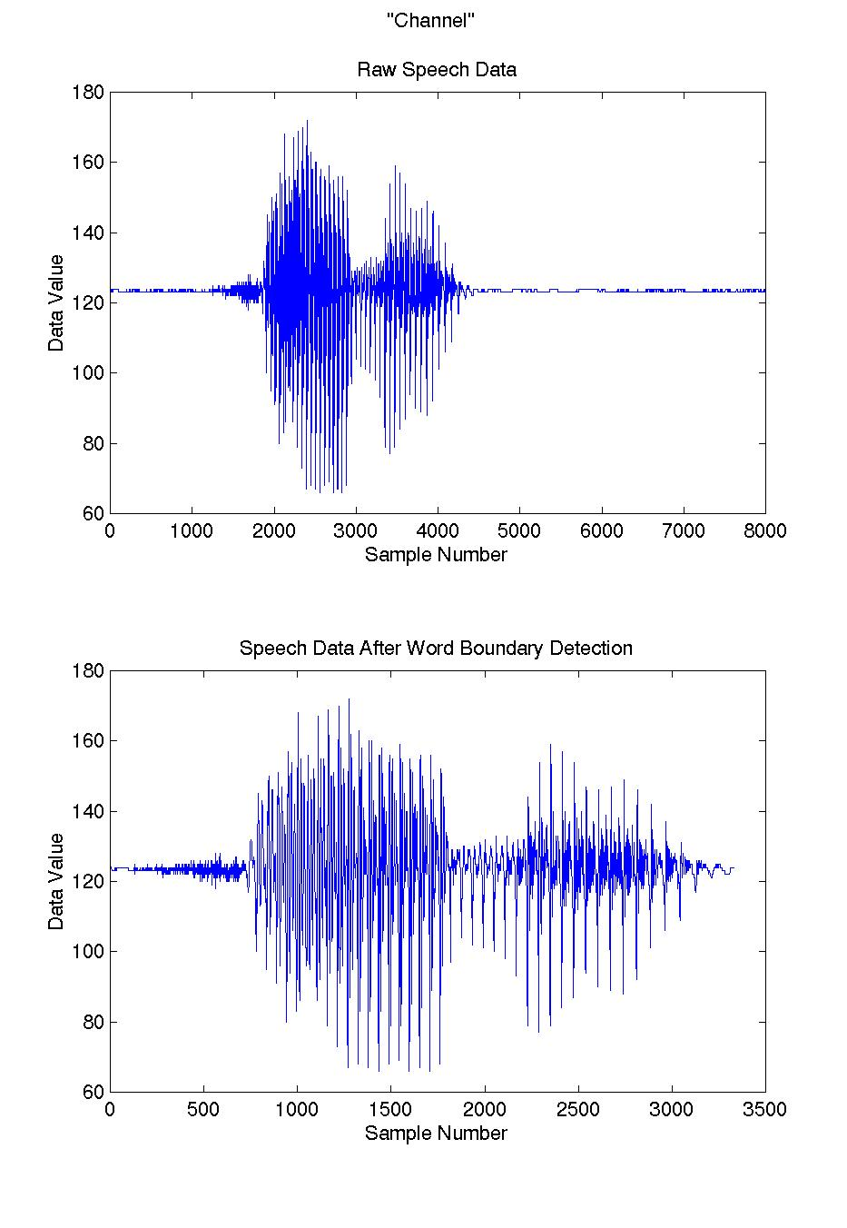

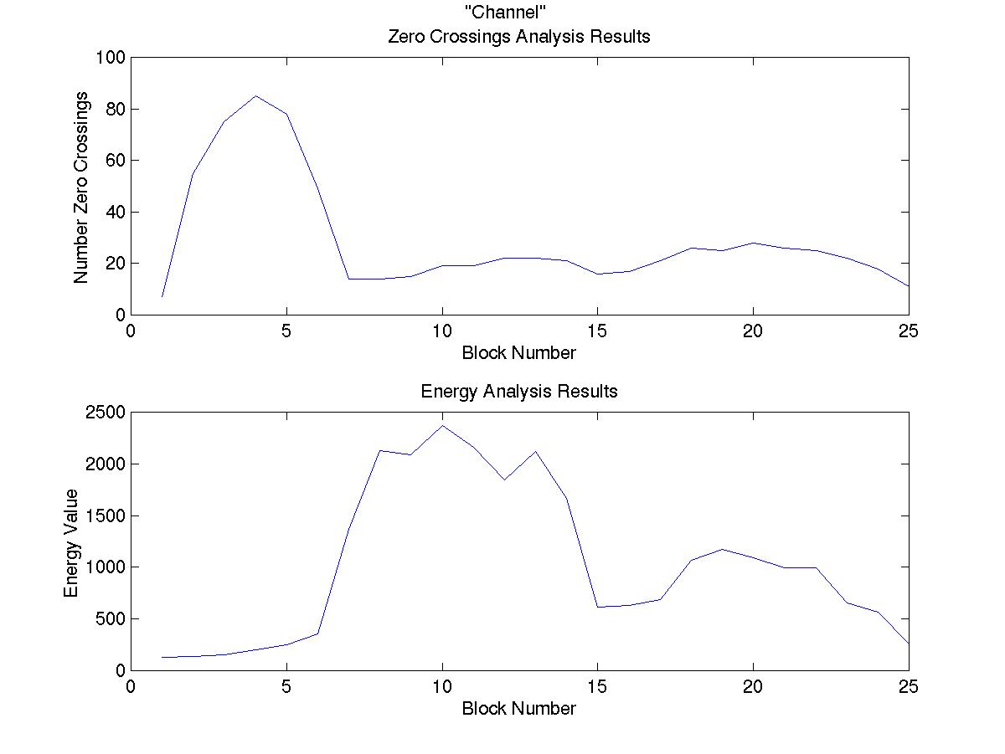
Using the results from the word boundary detector, the training and recognition algorithms were tested. The recognition algorithm was tested with the same data used for training the system. Two versions of the recognition and training algorithms were evaluated, one version performed the speech analysis over blocks of 256 samples of the input speech data, while the other version used 128 samples. The following tables
show the results of the recognition tests for the zero-crossings analysis, the energy analysis, and the combined analysis.

Recognition Results For Blocks of 256 Samples
Test Word | Zero-Crossings Result | Energy Analysis Result | Combined Result
down #1 | up | up | up
down #2 | up | up | up
down #3 | down | channel | invalid
down #4 | down | down | down
up #1 | up | up | up
up #2 | up | up | up
up #3 | up | up | up
up #4 | up | up | up
channel #1 | channel | up | invalid
channel #2 | channel | channel | channel
channel #3 | channel | tv | invalid
channel #4 | channel | channel | channel
tv #1 | tv | tv | tv
tv #2 | up | up | up
tv #3 | tv | tv | tv
tv #4 | up | tv | invalid
Total matches | 12 | 10 | 9
Recognition Accuracy | 75 % | 62.5 % | 56.3 %

Recognition Results For Blocks of 128 Samples
Test Word | Zero-Crossings Results | Energy Analysis Results | Combined Results
down #1 | up | down | invalid
down #2 | up | up | up
down #3 | down | down | down
down #4 | up | down | invalid
up #1 | up | down | invalid
up #2 | up | down | invalid
up #3 | up | up | up
up #4 | up | tv | invalid
channel #1 | channel | channel | channel
channel #2 | channel | channel | channel
channel #3 | channel | channel | channel
channel #4 | channel | channel | channel
tv #1 | tv | channel | invalid
tv #2 | up | up | up
tv #3 | tv | tv | tv
tv #4 | tv | tv | tv
Total Matches | 12 | 10 | 8
Recognition Accuracy | 75 % | 62.5 % | 50 %

From these results, the two version have about the same performance. However, the method using 128 samples in a block requires more memory than the 256 sample method, since each word will require twice as many blocks to represent it.

The Analog to Digital Conversion Interface
In the creation of the ADC interface, various obstacles were overcome. These ranged from deciphering poorly documented work from previous terms to determining the physical reasoning as to why certain approaches were not working to faulty test equipment. At first, the input ADC circuit was to be taken directly from a previous design for the same purpose completed by students in the previous term. Upon further investigation of this circuit, it was not clear as to why certain stages and components were used, nor even how they were connected. In light of this, it was decided that a re-design of the circuit would be beneficial from both the educational aspect and for reasons of comfort in the ability and stability of the circuit itself. In the re-design of the circuit, the first obstacle was to interpret the minimal detail provided on the specification sheet for the microphone element that was purchased. The only information given was a recommended voltage over the device and a small diagram on the connection. With no knowledge of the inner workings of the component, it seemed an impossible task to successfully connect the device. The signal emanating from the element itself appeared to have no measurable voltage and thus was assumed to require at least pre-amplification for the signal to be verified. This problem was brought to solution within the hour after the assumption that the component had variable impedance. Later on this was confirmed by the professor, but with one small twist - that is the device, originally assumed to be of variable resistance, turned out to have a variable capacitance. The next stumbling block faced was that our pre-amp appeared to be clipping the signal at one-tenth of its intended value. This was quickly revealed to be due to a combination of faulty equipment (an oscilloscope probe was set to 1x internally although the switch upon it indicated a setting of 10x) and a resistance being out by a magnitude. These two points were resolved and the design continued. Borrowing from the schematic of our colleagues in the previous term, it was assumed that the ADC0809 chip requires a stable signal held for proper conversion to take place. After much time and energy devoted to study of the specification sheet and operational testing, the sample and hold chip would not yield consistent results. In fact, the amplified signal actually appeared to be affected merely by connection to the powered chip. The entire stage was opted out of the new design under the new assumption that the ADC0809 chip would be self-sufficient in its conversion of signals. Testing later confirmed this assumption. The actual test performed to conclude this involved feeding the ADC0809 chip a steady clock pulse and connection of its input to an oscillating source. The start of conversion signal was triggered and the output was observed upon the oscilloscope. The frequency of the signal was varied and the output was observed. The results of this allowed for confirmation of the above-made assumption. Once the circuit was operational on both ends, and before connection, the signal’s amplitude was capable of reaching voltages that were twice the allowable limits to input to the ADC integrated circuit and therefore required to be limitations. The actual manner of implementing this was tried three separate ways. The first attempt involved running two diodes in series from ground to power and running the signal through the node between them. Theoretically, this would froward bias one of the diodes at the -0.7volt and +5.7volt marks. In practice, the voltage of the signal at that node ranged from –0.7volts to approximately 7.0 volts. This was deemed unacceptable and the idea was disregarded from further consideration. The next attempt involved utilizing the operational amplifier’s property to not being able to surpass its supply voltage. In light of this, a buffer was connected with the supplies connected to ground and +5volts. For reasons not fully investigated, the circuit seemed to oscillate up to nearly +8volts at the application of a loud whistle to the circuit. The investigation ceased upon the implementation of our third and final attempt to limit the signal’s swing with a 5.1volt Zener diode. This final implementation allowed for a simple method of limitation of the signal near the –0.7volt and 5.2volt levels. In the end, the design of the input ADC circuit proved to work fully.

The on-chip support for the ADC converter is done with the help of our aforementioned colleagues. The actual interfacing code was modified slightly to tailor it to our specific needs. The details of our modifications can be seen in the code and involve adding an extra process to their input_reader.vhd to ensure synchronicity of the input data.

Test cases that were used to confirm proper operation

The Control Path

Testing for the control path was done extensively in simulation and confirmed with the results of real-time operation. Alone, a battery of simulations was performed in order to examine the behavior of the entity under various situations. In particular, simulations were done to test the training and initialization in every possible configuration. This was to ensure that nothing the user could do would cause the device to operate incorrectly. In the proceedings of these simulations, some of the problematic issues that arose did not pertain to the actual digital operation, but to that of the overall device. The sequence of training was very highly dependent upon the successful operation of the device. If, for instance the voice training was done without the knowledge of the ambient noise, the information in the voice training could potentially be rendered useless. Another problem, this one more directly related to the digital implementation, was the issue of when the surf function was sensitive to the command to cease and exit into normal active operation. It was found that if the command to cease was issued at a particular time, while the surf function was counting its delay, the request would be ignored. This proved to be potentially fatal to the reliability of the surf function and was uncovered only after simulations were done to specifically target that aspect of the design. In real-time testing, the control path was tested used dummy signals and longer time durations to first confirm the accuracy of the simulations before the large-scale integration of the various parts. Although it proved rather tricky to manipulate the various signals manually and with the correct sequence, the majority, if not all of the functionality was confirmed to the designer’s satisfaction.

References
1 Asiedu-Ampem, P. et al. EE 552 Application Notes – Clock Divider. Internet: 1998.
www.ee.ualberta.ca/~elliot/ee552/studentAppNotes/98f/clk_div/clk_div.html

2 Bensler, T. and E. Chan. Interfacing External SRAM. Internet: 1999.
www.ee.ualberta.ca/~elliot/ee552/studentAppNotes/99w/SRAM/

3 Bo, N., K. Leung, and D. Ritter. FIR Filter Design. Internet: 1999.
www.ee.ualberta.ca/~elliot/ee552/studentAppNotes/99w/FIRFilter/

4 Furui, S. Digital Speech Processing, Synthesis, and Recognition. New York: Marcel Dekker,
Inc., 1989.

5 Gould, D., K. Grant, and A. Stanley-Jones. Voice-Activated RC Car. Internet: 1999.
www.ee.ualberta.ca/~elliot/ee552/projects/99w/voice_activated_rc_car/

6 Robinson, T. Speech Analysis. Internet: 1998. svr-www.eng.cam.ac.uk/~ajr/SA95/

7 Yadunandana, R. Speech Recognition Using Hidden Markov Models. Internet 1999.
www.angelfire.com/ny/yadunandana/report1.html

8 Willmott, K. IR Remote Control Codes. Newsgroup Posting displayed via Internet 1999.
http://www.hut.fi/Misc/Electronics/docs/ir/ircodes.html
http://www.ee.washington.edu/eeca/text/ircodes.txt

9 University of Washington, Circuit Archive, Internet 1999
http://www.ee.washington.edu/eeca/circuits/

