eSAFETM
Resource Requirements

Stephen Caplan
Javan Gargus
Kevin Hackett
Paul Somogyi

Date: October 6, 1998
Instructor: Duncan Elliott
Class: EE 552
Table of Contents

Project Description 2
Simulation and Design 3
Ethernet Interface 3
Ethernet 3
Ethernet Receiver Interface 4
CRC Generator 7
Bf_control 9
Blowfish Encryption Unit 10
Memory Unit 13
General Agenda 15
Resource Allocation: 15
Time Line: 15
Conclusions 16
Appendix A: Simulation Waveforms 17
Appendix B: VHDL Code 18
Appendix C: Schedules 19

Project Description

Network traffic over a LAN or the Internet is inherently vulnerable to a number of forms of attack. Primarily, unauthorized access to a private data stream could compromise system security and personal privacy. The protection of such data is the prime concern of our project, the eSAFE network bridge. It will provide secure end-to-end data flow with encryption and decryption of network traffic.

The eSAFE device will read and write to two separate ethernet segments and provide data security by means of blowfish encryption. On the incoming pipe, the data will first be read by our ethernet transceiver. The data portion of the current frame will then be encrypted while the headers are preserved for use on the outgoing pipe. After encryption, the frame will be immediately transmitted onto the outgoing pipe.

The blowfish algorithm is a symmetric encryption routine that requires the same key to be used on both ends of the data stream to properly encrypt and decrypt the data. This key is fundamental to the security of the system. In our current implementation, this key will be hard coded into the systems for ease of design and simulation. Blowfish requires the ability to read and write to a 4k lookup table to generate its cyphertext. A memory controller is required to accommodate for these needs.

To provide a minimal but functional system, our current implementation focuses on the ethernet interface, memory controller, LUT generator and blowfish encryptor. A number of components and features have been left out of this design stage. These include the keypad, LCD display, send buffer and TCP extensions.

Compilable code is included for the ethernet, blowfish, blowfish arbitrator, and LUT arbitrator and memory access interface. Simulations are included for the ethernet, blowfish arbitrator, and LUT access.

A design hierarchy is included below that illustrates the interconnection between entities. To this point, components, design and simulation have been done only on a modular basis, which is to say that no integration between components has been tested.
chip
ethernet
ethernet
Receive Buffer
Receive Buffer
Progressive Blowfish
Progressive Blowfish
Send Buffer
Send Buffer
Blowfish
Blowfish Control
LUT Access
LUT Generator
bf_enc
bf_counter
crc
crc

Simulation and Design

Ethernet Interface

This component functions as a controller for the National Semiconductor DP83910A to provide an interface between the physical ethernet medium and the rest of the eSAFE encryption system. Additionally, a DP83922 twisted pair transceiver will be used to drive and read data from the physical medium. The physical medium is 10BaseT ethernet, carried over CAT 3 UTP cable.

This ethernet controller provides a serial data stream to the rest of the system along with handshaking and control lines. On the inbound interface such issues as collisions, broken/incomplete packets and CRC checking are dealt with. The outbound interface will calculate and append a CRC checksum to a frame. It will transmit properly formed ethernet packets, in conformance with the IEEE 802.3 specifications for ethernet, including proper retransmission on collisions.

The following diagram, shows the ethernet interface to the external network components.

twisted pair

Ethernet
Controller

National
DP83910A

National
DP83922
Ethernet
Tranciever

ethernet

The ethernet controller is composed of three main functional units: the receive interface, transmit interface and CRC checksum generator. At present, the receiver and crc generator can be compiled and simulated, the transmitter is under development, but it’s chip space requirement is estimated to be smaller than the receiver.

Currently, the ethernet components require a total of 8 I/O pins for each interface, or 16 pins for the entire system. The crc generator requires 153 logic cells, and the receiver requires 146 cells. For full functionality we’ll require 2 instantiations of each of these (the CRC generator may be left of the receiver to conserve space), so the total logic cell count for ethernet comes to:

Reciever: 146 * 2
Transmitter: 140 * 2 (estimated)
CRC: 153 * 2
--------------------------------
Total 878 cells

It is important to consider that these modules have not been optimized, and a 30-40% cell reduction is considered possible.

Ethernet Receiver Interface

As diagrammed above, this interface receives serial data from the DP83910A chip. The state table for the receiver is shown below:
Recv_null
Recv_1
Recv_10
Recv_101
Recv_1010
Recv_10101
Recv_101010
Recv_1010101
1
0

1
1
1
1
Set Count = 96
0

0

1
1
1
0
0
0
0
When count = 0
Set count = 32
When count = 0

Frame_Address
While count > 0
Count = Count -1

Frame_Length
While count > 0
Count = Count -1

When count = 0
Set count = 16
Frame_Data
While count > 0
Count = Count -1

When count = 0
Set count = Length
Frame_CRC
While count > 0
Count = Count -1

The receiver operation begins when a carrier is detected on the incoming channel (CRS is asserted). It then must remove the ethernet preamble (a 7 bytes string of 1-0-1) which is used by the 83910A to synchronize it's PLL with the data. A simulated start delimiter pattern match is demonstrated below:

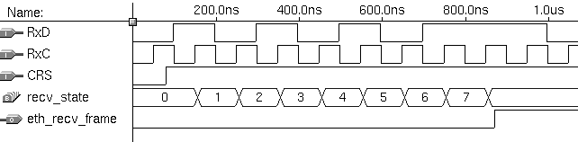
Input data stream 10101011
Carrier Sense: Notifies of incoming data
States progress since data matches set pattern
Pattern Matched, eth_recv_frame asserted
So while the preamble is received, the systems will oscillate between state 0 and 1, but will not assert eth_recv_frame until the start delimiter has been receiver.
After this frame delimiter has been detected, the following 96 bits will correspond to the destination and source ethernet MAC address (6 bytes, 48 bits each).

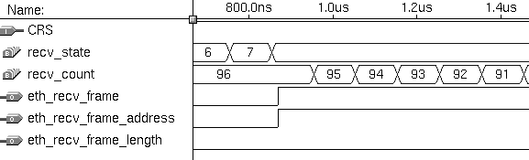
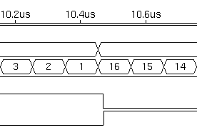
Address Start … 88 bits …
Address End

The next 16 bits are the length field that specifies the length of the data field. As the bits arrive they are shifted into a register that will later be used as a counter to mark the end of the data field. In practice if this value is below 384 bits (48 bytes) it indicates that padding is present. So we would always need to count through a minimum of 384 bits. However, in simulation this not practical, so we've allowed shorter values. The simulation below shows the input to the shift register, which is then copied to our bit counter:

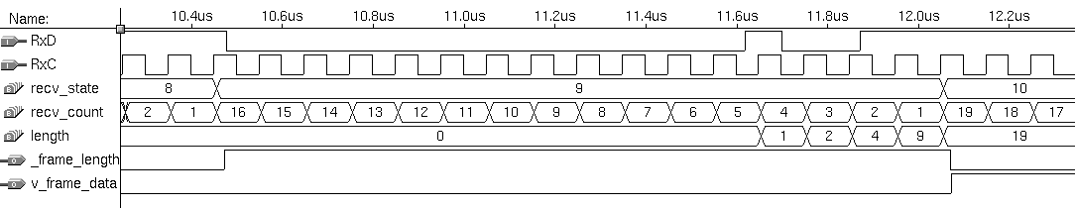
16 bit Frame Length

Bit Stream - 0000000000010011 = 19
Payload Data Starts
Shift Register
Bit Counter

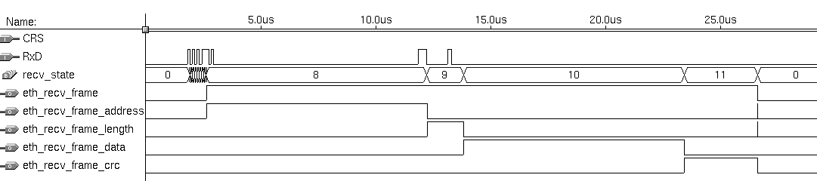
After this follows however many bits of data were specified in the length field above, and then a 32 bit CRC checksum, so an entire frame might look like this:
Start Delimeter
96 bit Address 16 bit Length N = 96 bit Data 32 bit CRC
Length = 1100000 = 96 bits
Frame

CRC Generator

CRC works by assuming that a data stream is an enormous binary number. If this number is divided by a second fixed binary value, the remainder is our CRC checksum. In order to confirm valid data, the recipient will follow the same process and ensure that the two checksums correspond.

The difficulty with this method comes with the size of the data stream. In an ethernet implementation, this could be as long as 12000 bits, which easily exceeds the capabilities of a standard 32bit registers. To simplify this, we can do the division a little differently, while considering that we are only interested in the remainder of the division, not the quotient. By working with a register the same size as our target checksum, we are able to shift the serial data through the register, while simply using XORs as linear feedback to the register. Basically, it works like this:

Load the register with zero bits.
Augment the message by appending N zero bits to the end of it.

While (more message bits)
Shift the register left by one bit, reading the next bit of the augmented message into register bit position 0.
If (a 1 bit popped out of the register during step 3)
Then Register = Register XOR Generator Poly.
End

The register now contains the remainder

Source: A Painless Guide to CRC Error Detection Algorithms
http://www.repairfaq.org/filipg/LINK/F_crc_v3.html

The CRC generator was tested with a number of generator polynomials of varying length, on various serial data streams. For simplicity and brevity, only test case with a 4 bit (N=4) CRCs will be presented here.

We will use the following inputs:

Generator Polynomial : 10011
Original message : 1101011011
Message after appending N zeros : 11010110110000

Through long division, we get the following result:

1100001010 = Quotient
_______________
10011 ) 11010110110000 = Augmented message
10011,,.,,....
-----,,.,,....
10011,.,,....
10011,.,,....
-----,.,,....
00001.,,....
00000.,,....
-----.,,....
00010,,....
00000,,....
-----,,....
00101,....
00000,....
-----,....
01011....
00000....
-----....
10110...
10011...
-----...
01010..
00000..
-----..
10100.
10011.
-----.
01110
00000
-----
1110 = Remainder = THE CHECKSUM!!!!

Source: A Painless Guide to CRC Error Detection Algorithms
http://www.repairfaq.org/filipg/LINK/F_crc_v3.html

The same result can be seen in the following test case:

Data Stream 1101011011 End of Data Mark

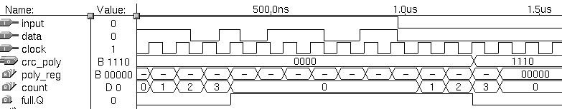

Shift Register Full Correct CRC Checksum Output

It is important to note that the minimal acceptable input length is N (the width of our CRC output). Given less than N bits in the incoming data stream, no CRC output will be produced.

Bf_control

About bf_control

The bf_control component controls access to the blowfish encryptor block. It handles requests to use the Blowfish encryption algorithm from three different sources, and mediates between them to ensure that no conflict exists. The operation of the unit is as follows:
1. Waits for one of the three bfctl_req_X lines to be asserted high.
2. When one of the lines goes high, the bf_control unit sets the internal bfctl_mux_select line to route all lines from the entity being served to the blowfish block. This includes bfctl_key_select, bfctl_encrypt_decrypt, brctl_data_ready_to, bfctl_data_ready_from, bfctl_data_in, and bfctl_data_out. Also, the bfctl_ack_X line is raised to tell the requesting unit that their request is being serviced. Note that the only lines that the bf_control block uses for input are the three bfctl_req_X and bfctl_done_cycle, and uses the three bfctl_ack_X for output.
3. All communication is now carried out directly between the requesting unit and the blowfish block. No new requests are accepted.
4. When the bfctl_done_cycle signal is asserted and the bfctl_req_X that was originally asserted becomes negated, then bf_control cycle will once again look for new connections.

Resource Usage

The following is an extract from the bf_control.rpt file:

***** Logic for device 'bf_control' compiled without errors.

** RESOURCE USAGE **

Total logic cells used: 34/1152 ( 2%)
Average fan-in: 3.00/4 ( 75%)
Total fan-in: 102/4608 ( 2%)

Total logic cells required: 34
Total flipflops required: 0
Total packed registers required: 0

Since the design only requires one of these units, it can be concluded that this unit does not require a significant percentage of the logic cells, and does not have to be optimized further. However, note that it has has, in total, 8 32 bit data lines, which may cause a wiring problem. However, since it is small, we are confident that it will be possible to find a suitable location for this unit on the chip. Furthermore, it can be modified to use 8bit buses instead, although this will require the addition of buffer stages to accumulate 32 big numbers for the blowfish unit to process.

Testing

Testing the bf_control unit is quite easy, since it only pays attention to a handful of the many inputs and outputs. All the rest are merely routed via the bfctl_mux_select signal. Thus, what was done is to set the *a set of lines to 1 and the *b set of lines to zero. The bfctl_req line was asserted, and the unit correctly generated the bfctl_ack_a and ignored requests from the bfctl_req_c line. Then, the unit waited for both bfctl_done_cycle to be asserted and bfctl_req_a to be negated. Next, when bfctl_req_b was asserted, it could be seen that the bfctl_mux_select line correctly chose the output to the blowfish block to be the inputs from the *b lines (this transition could be seen because all of the b input were different than the a inputs. Note that the ack signals were not originally present. However, they were deemed necessary, since the bf_control multiplexors could switch over the single lines more quickly than the data bus lines. Thus, it would be possible for the bfctl_data_ready_to_X lines to signal that the data was valid before the bfctl_data_in_X were fully selected. Thus, the acknowledgements are needed so that the requesting entities can assert their data ready lines after the multiplex switching has been done.

Blowfish Encryption Unit

In order to provide encryption of the data, we will implement the blowfish encryption algorithm. This algorithm was developed by Bruce Schneier and is available in the public domain. In order to implement the algorithm properly in VHDL, it is necessary to break down the unit into three separate components -- the blowfish component (blowfish.vhd), the blowfish encryption component (bf_enc.vhd), and the blowfish counter component (bfcounter.vhd). The latter two components are necessary in order for the blowfish component to work properly.

The blowfish.vhd component basically starts and ends the encryption process. Upon sending a signal to the ethernet interface, it begins to read in data. This data comes in the form of two 32-bit blocks XL and XR. Once all of the data is read in, it sends a signal (data_ready_to) low. Now it is time to actually encrypt the data that has been read in.

The bf_enc.vhd component is responsible for encrypting the data. In order to do this, a for loop must be created for values of p-box 0 to 15. In VHDL, we implemented this via a counter (bfcounter.vhd). The counter basically counts up for encryption and down for decryption insofar as the p-boxes are concerned. It does, however, also count the s-boxes in order to implement the function that is referred to by the following figures:

Function F:
begin
xL/(4) = a,b,c,d
where a,b,c,d are 8-bit quarters
F(xL) = ((S1,a + S2,b mod 2^32) XOR S3,c) + S4,d mod 2^32
end

Note: the original 64-bit data will be represented with and x and the P-array will be denoted Pi.

Begin

i < 16

x/2 = xL & xR
Swap xL and xR
Swap xL and xR
xR = xR XOR P17
xL = xL XOR P18

xL = xL XOR Pi
xR = F(xL) XOR xR

Recombine xL and xR

End

The VHDL code for the three components described above are included at the end of this document. These components all compile successfully and simulation is in progress. The total cell count is 783 of 1152 available. Hence, it does fit on one chip, but integrating the other components may be tight. Nevertheless, it should be noted that these components might still be optimized by using the Altera Recommended State Diagrams as was already suggested on the news group. This method of optimization should not be too difficult by following the example in the news group; however, it is good to know that without optimization, the encryption part of the eSafe project still allows room for other parts as well.

Memory Unit

The initial design included a module called memory_unit that arbitrated the read and write access to an external memory, since different components read and write to the same memory. The data size was a generic parameter, to allow for code reuse. The design required 3 different memories: two independent 8-bit data bus memories for buffering transmit packets, and a 32-bit data bus memory for the blowfish algorithm lookup tables.

The memory_unit module was developed using an 8-bit data bus. However, it did not work correctly when the data size was increased to 32 bits. For the LUT, there was another module developed which arbitrated the read access; since both the blowfish encryption module and the LUT generator need read access, while only the LUT generator needs write access. Since a different version of the memory_unit module would be needed for the LUT, it was merged with the lut_access module. This module, referred to as memory_unit3, arbitrates memory access between two readers and one writer.

The memory chosen for the project is asynchronous SRAM, with an access time of 12ns. Synchronous SRAM would probably have been easier to work with, but the smallest chips available are 1Mbit, which is far beyond the minimum 32Kbit required for the LUT. Since the asynchronous memory responds to falling edges on the control signals, it is necessary to clock all of these signals; also, the address (and during a write, the data) signals must remain asserted while the chip is enabled, so they must also be clocked.

The state machine for the memory unit is shown below. It waits for one of three consumers to request a memory access. When the access is finished, the done signal for that consumer is asserted. Thus, requests from other consumers will block until the current request is completed. Note that there is only one state that chooses which request to acknowledge, which means that the first consumer checked will always get priority. Two more "wait for request" states are required that have different priorities, which would allow for a round-robin type of scheduling.

wait_req

read_req_a
write_req
read_req_b
read_req_a
write_req
read_req_b

read_wait_a
write_wait
read_wait_b

ram_address = read_address_a ram_address = read_address_b ram_address = write_address
ram_data = Z ram_data = Z ram_data = write_data
ram_ce = 0 ram_ce = 0 ram_ce = 0
ram_oe = 0 ram_oe = 0 ram_we = 0

Unfortunately, the currently implementation does not meet the timing requirements imposed by the data rate of the 10Mb/s ethernet. Each read or write request requires three clock cycles to complete; this is a 60ns latency at a 20ns clock period. Since blowfish requires 16 x 4 memory accesses, this requires 64 x 60ns = 3840ns; of course, blowfish will also require time for its control and logic. This time can be minimized by performing operations while waiting for the memory. For full duplex operation, blowfish must complete in approximately 6400/2 = 3200ns. Thus we have already exceeded this bound. Further work is required to reduce this to a maximum of 40ns. Since we are trying to minimize space, this also reduces the possible techniques for increasing the speed of the memory access cycle. The number of logic cells used is 93 currently, down from a high of over 150.

General Agenda

Resource Allocation:

Task | Leader | Consultant
Ethernet | Steve | Paul
RAM/Buffering | Paul | Javan
Encryption | Kevin | Javan
Keypad | Javan | Kevin
IP Level | Paul | Steve
LCD | Javan | Kevin
Overall Interfacing | All | All
Integration and Unit Testing | Javan | All

Time Line:
Expected Date of Completion  (yyyy/mm/dd) | Stage | Class Deadline  (denoted with ☺) | Completion Date
1998/09/18 | Project Ideas and General Plan |  | 1998/09/18
1998/09/21 | Precise Design Goals and System Scope |  | 1998/09/21
1998/09/22 | Project Proposal | ☺ | 1998/09/22
1998/09/25 | General Parts List |  | 1998/09/25
1998/09/28 | Block Diagrams and Flow Diagrams |  | 1998/09/28
1998/09/30 | (Early Bonus) Application Notes |  | 1998/09/30
1998/10/02 | Interface Design |  | 1998/10/02
1998/10/02 | Detailed Individual Task Lists |  | 1998/10/02
1998/10/05 | Detailed Parts List |  | 1998/10/05
1998/10/05 | Specific I/O Diagrams
1998/10/05 | Preliminary VHDL Code |  | 1998/10/05
1998/10/06 | Specification | ☺ | 1998/10/06
1998/10/19 | Basic Unit VHDL |  | 1998/10/27
1998/10/19 | Basic Hardware Modules
1998/10/27 | Resource Requirements | ☺
1998/10/29 | Application Notes | ☺ | 1998/09/30
1998/11/07 | Complete Unit VHDL
1998/11/07 | Simulate/Test Unit VHDL
1998/11/08 | Integrate VHDL
1998/11/08 | Test Integrated VHDL
1998/11/10 | Simulation Documentation | ☺
1998/11/16 | Build System / Program FPGA
1998/11/19 | System Testing
1998/11/25 | Final Report | ☺

Conclusions

It is clear that our current design will not fit in the chip; depending on how well our space optimizations reduce our design, it might potentially fit. We have a multitudinous array of viable options to vigorously pursue in order to ameliorate our dire predicament. The first is to use two chips; the second is to gut our design until there is nothing left but an empty hulk that does not in any way resemble the initial design; the third is to use a larger capacity chip. We would prefer to follow the first option since allows us to develop a product that meets as many of our original design goals as possible.

Appendix A: Simulation Waveforms

Appendix B: VHDL Code

Appendix C: Schedules
Detailed Agenda (only coding tasks included)

Task | Victim | Start Date | End Date | Hours Required
- code progressive encryptor | Kevin | Now | Nov 7 | 10
- optimize blowfish module | Kevin | Now | Nov 7 | 8
- unit test bf_enc module | Kevin | Now | Nov 8 | 6
- unit test encryption module | Kevin | Now | Nov 8 | 2
- unit test blowfish module | Kevin | Now | Nov 8 | 4
- research test bench testing on Mentor Graphics | Kevin | Now | Nov 8 | 4
- research Altera command files | Kevin | Now | Nov 7 | 4
- design overall test plan | Javan | Nov 8 | Nov 12 | 8
- control quality | Javan | Now | Nov 10 | 10
- code lut_gen module | Javan | Now | Nov 8 | 12
- unit test lut_gen module | Javan | Now | Nov 9 | 4
- steal code from App Notes for keypad | Javan | Now | Nov 7 | 1
- steal code from App Notes for LCD | Javan | Now | Nov 7 | 1
- bake cake | Javan | Nov 8 | Nov 8 | 1
- optimize memory access | Paul | Now | Nov 2 | 6
- unit test memory access | Paul | Now | Nov 3 | 2
- code receive "buffer" / blowfish controller | Paul | Now | Nov 7 | 8
- unit test receive buffer | Paul | Now | Nov 8 | 4
- code send "buffer" / transmit ethernet controller | Paul | Now | Nov 7 | 8
- unit test send buffer | Paul | Now | Nov 8 | 4
- bake cookies | Paul | Nov 8 | Nov 8 | 1
- complete transmit ethernet | Steve | Now | Nov 7 | 8
- unit test crc | Steve | Now | Nov 8 | 4
- unit test receive | Steve | Now | Nov 8 | 4
- unit test send | Steve | Now | Nov 8 | 4
-research synchronizing with encryption | Steve | Now | Nov 8 | 2
-get external 20 MHz clock | Steve | Now | Nov 8 | 1
- bbq steaks | Steve | Nov 8 | Nov 8 | 1
- learn time travel (high priority task) | Kevin, Javan, Paul, Stephen | Yesterday | Last year | -12

This resulted from a heinous plot to defy our intentions on the part of a sinister third party, whose identity is unknown but is suspected to possibly be connected with an underground organization that is masterminded by the overlords of Altera who enjoy making students and engineers and professors and other miscellaneous people suffer to the fullest extent of hell.

